Project Design Phase-II
Data Flow Diagram & User Stories

Date | 08-12-2025
Team ID (SkillWallet ID) | SWUID202560126
Project Name | Book a Doctor
Maximum Marks | 4 Marks

Data Flow Diagrams:
A Data Flow Diagram (DFD) illustrates how data moves within the Book a Doctor platform. It captures how patients, doctors, and admins interact with the system, how appointment data flows between different modules, and how records are stored securely.
DFD Level 0
External Entities:
- Patient
- Doctor
- Admin
- Notification / SMS Gateway
System:
- Book a Doctor Platform (centralized system)
High-level Data Flows:
- Patient → Book a Doctor: Search Doctors, Book Appointment, Upload Reports, Chat
- Doctor → Book a Doctor: Manage Schedule, Accept/Reject Appointments, Share Prescriptions
- Book a Doctor → Notification Gateway: Appointment reminders, status updates
- Admin ↔ Book a Doctor: Doctor verification, system monitoring, dispute handling
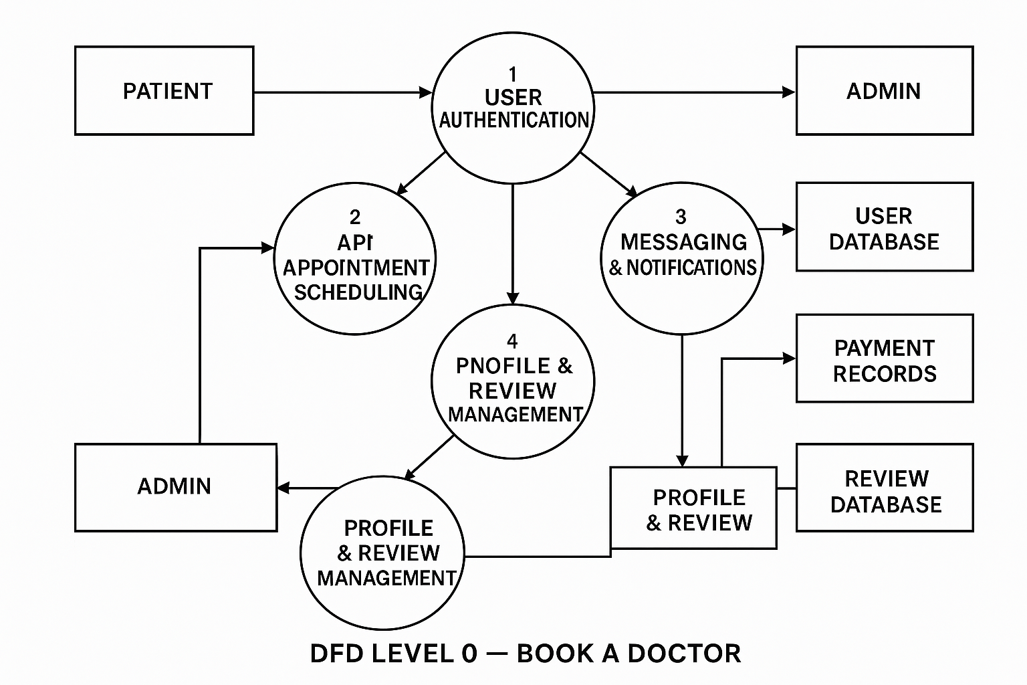User Stories

User Story Table – Book a Doctor
User Type | Functional Requirement (Epic) | User Story / Task | Acceptance Criteria | Priority | Release
Patient | User Authentication | As a patient, I want to sign up and log in so I can book appointments. | Valid user is created; incorrect login returns error; JWT token is generated. | High | Sprint-1
Doctor | User Authentication | As a doctor, I want to register and complete my profile so patients can find me. | Doctor role saved; profile fields validated; dashboard visible. | High | Sprint-1
User  (Patient/Doctor) | Account Recovery | As a user, I want to reset my password so I can recover my account. | Email sent; token validated; password successfully reset. | Medium | Sprint-2
Patient | Doctor Search | As a patient, I want to search and filter doctors so I can find the right specialist. | Filters working; search results accurate; pagination enabled. | High | Sprint-1
Patient | Appointment Booking | As a patient, I want to book an appointment so I can consult a doctor. | Appointment saved; doctor notified; timeslot validated. | High | Sprint-1
Doctor | Schedule Management | As a doctor, I want to manage my availability so patients can book valid slots | Availability updated, conflicts prevented, calendar visible | High | Sprint-1
Patient/ Doctor | Appointment Approval | As a doctor, I want to accept or reject appointments | Patient receives alert, status updated to Accept/Rejected | High | Sprint-1
Patient/ Doctor | Real-Time Chat | As a user, I want to chat in real-time for clarifications. | Messages delivered instantly; stored in DB; unread counts update. | Medium | Sprint-2
Patient | Medical Records Upload | As a patient, I want to upload reports so the doctor can review them | File upload succeeds, preview available, stored securely | High | Sprint-2
User | Notifications | As a User, I want to receive remainders for upcoming appointments. | Notifications sent via email/SMS; marked as read | Medium | Sprint-2
Patient | Appointment History | As a patient, I want to view past and upcoming appointments. | History displayed; sorted by date; view details | Medium | Sprint-2
Admin | Doctor Verification | As an admin, I want to verify doctors to ensure platform trust | Verification badge applied; documents reviewed | High | Sprint-1
Admin | Dispute Handling | As an admin, I want to resolve disputes between patients and doctors | Dispute logged; status updated; users notified. | High | Sprint-3
User | Profile Management | As a user, I want to update my personal details securely. | Details updated; validation applied; confirmation shown. | Medium | Sprint-2
Patient | Cancel Appointment | As a patient, I want to cancel a booking if I can’t attend | Doctor notified; slot freed; cancellation policy enforced. | Medium | Sprint-3
Doctor | Appointment Notes | As a doctor, I want to add notes during consultation. | Notes saved; visible to doctor only; timestamps applied. | Medium | Sprint-3
System | System Logging | As a system, I must log important actions for security. | Logs stored for login, booking, and cancellation events. | Medium | Sprint-1
Patient/Doctor | In-app Report Preview | As a user, I want to view uploaded documents within the app. | Preview loads; formats supported; secure access enforced. | Medium | Sprint-3

